## **CGMM**

## **CASE STUDY**

1. **TEXT, AUDIO, VIDEO FILE FORMATE.**

* **TEXT :-**

RTF - Rich Text Format is the primary file format introduced in 1987 by Microsoft with the specification of their published products and for cross-platform documents interchange.

Plain text - Plain text files can be opened, read, and edited with most text editors. commonly used are Notepad (Windows), Gedit or nano (Unix, Linux), TextEdit Mac OS and so on. Plain text is the original and popular way of conveying an e-mail.

* **AUDIO :-**

WAV - It is the most popular audio file format in windows for storing uncompressed sound files. In order to attain the reduced file size it can also be converted to other file formats like MP3.

MP3 - MPEG Layer-3 format is the most popular format for storing and downloading music. The MP3 files are roughly compressed to one-tenth the size of an equivalent WAV file.

OGG - A free, open source container format that is designed for obtaining better streaming and evolving at high end quality digital multimedia. It can be compared to MP3 files in terms of quality.

AIFF - A standard audio file format used by Apple which is like a WAV file for the Mac.

WMA - It is a popular windows media audio format owned by Microsoft and designed with Digital Right Management (DRM) abilities for copyright protection.

RA - Real Audio format is designed for streaming audio over the Internet. The digital audio resources are usually stored as a computer file in computer’s hard drive or CD/DVD. Besides the variety of audio file formats available, the most common formats are wave files.

* **VIDEO :-**

AVI (Audio/Video Interleave) - AVI is the video file format for Windows. Here sound and picture elements are stored in alternate interleaved chunks in the file.

MPEG (Moving Picture Experts Group) - MPEG is a standard for generating digital video and audio compression under the International Standards Organization by the group of people. The group has developed MPEG-1, the standard on which Video CD and MP3 are based, MPEG-2, the standard that supports products as Digital Television set top boxes and DVD, MPEG-4, the standard for multimedia and mobile web.

1. **MULTIMEDIA AND ITS ARCHITECTURE.**

The word multi and media are combined to form the word multimedia. The word “multi” signifies “many.” Multimedia is a type of medium that allows information to be easily transferred from one location to another.

Multimedia is the presentation of text, pictures, audio, and video with links and tools that allow the user to navigate, engage, create, and communicate using a computer.

Multimedia refers to the computer-assisted integration of text, drawings, still and moving images(videos) graphics, audio, animation, and any other media in which any type of information can be expressed, stored, communicated, and processed digitally.

**ARCHITECTURE :-**

The architecure of multimedia system may be described as a four-level hierarchy. The four-layers (lowest (bottom) layer first) of the architecture, known as the *RT architecture* (Real-time information handling), are:

**Network Subsystem (Layer 1)**

-- This layer takes care of the functionalities up layer 3 in the OSI model . Network specific functions depend on the technology used in this layer . Essentially this level provides a possible connection through a network with a specified bandwidth and error probability as supported by the underlying technology.

**End-to-End QoS Control(Layer 2)**

-- This layer maintains the connection between the source and destination and can be conceptually viewed as a single connection -- even though there may be physically many more. Each connection is managed to ensure that a given Quality of Service (Qos) is maintained.

**Media Management (layer 3)**

- This layer provides *generic* services to applications in so far as media management is concerned. A primary functions is synchronisation across the media .

**Application (Layer 4)**

-- The direct interface with the user. The applciation wil also interface with the operating system, if required -- for example calls to storage media or specific library functions (subrou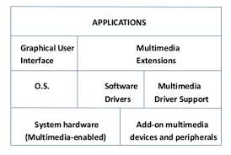tines).

1. **MULTIMEDIA AUTHORING TOOLS.**

Multimedia authoring is a process of assembling different types of media contents like text, audio, image, animations and video as a single stream of information with the help of various software tools available in the market. Multimedia authoring tools give an integrated environment for joining together the different elements of a multimedia production. It gives the framework for organizing and editing the components of a multimedia project. It enables the developer to create interactive presentation by combining text, audio, video, graphics and animation.

**Features of Authoring Tools**

* **Editing Features-** Most authoring environment and packages exhibit capabilities to create edit and transform different kinds of media that they support.
* **Organizing Features-** The process of organization, design and production of multimedia involve navigation diagrams or storyboarding and flowcharting.
* **Visual programming with icons or objects-** It is simplest and easiest authoring process. For example, if you want to play a sound then just clicks on its icon.
* **Programming with a scripting language-** Authoring software offers the ability to write scripts for software to build features that are not supported by the software itself.
* **Document Development tools-** Some authoring tools offers direct importing of pre-formatted text, to index facilities, to use complex text search mechanism and to use hypertext link-ing tools.
* **Interactivity Features-** Interactivity empowers the end users to control the content and flow of information of the project. Authoring tools may provide one or more levels of interactivity.
* **Simple branching-** Offers the ability to go to another section of the multimedia production.
* **Conditional branching-** Supports a go to base on the result of IF-THEN decision or events.
* **Playback Features**- When you are developing multimedia project, you will continously assembling elements and testing to see how the assembly looks and performs.
* **Supporting CD-ROM or Laser Disc Sources-** This software allows over all control of CD-drives and Laser disc to integrate audio, video and computer files.
* **Supporting Video for Windows-** Videos are the right media for your project which are stored on the hard disk. Authoring software has the ability to support more multimedia elements like video for windows.
* **Hypertext-** Hypertext capabilities can be used to link graphics, some animation and other text. The help system of window is an example of hypertext.
* **Cross-Platform Capability-** Some authoring programs are available on several platforms and provide tools for transforming and converting files and programs from one to the other.
* **Run-time Player for Distribution-** Run time software is often included in authoring software to explain the distribution of your final product by packaging playback software with content.
* **Internet Playability-** Due to Web has become a significant delivery medium for multimedia, authoring systems typically provide a means to convert their output so that it can be delivered within the context of HTML or DHTML.

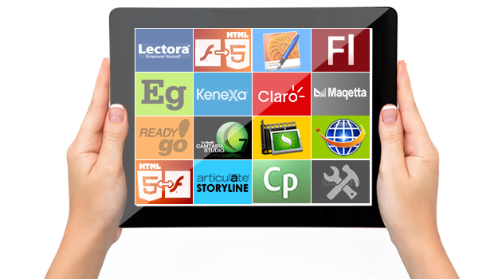

1. **ANIMATION PRINCIPLES AND FORMATES.**

**Principles Of Animation :-**

Animation is defined as a series of images rapidly changing to create an illusion of movement. We replace the previous image with a new image which is a little bit shifted. Animation Industry is having a huge market nowadays.

There are 12 major principles for an effective and easy to communicate animation.

* Squash and Stretch :- This principle works over the physical properties that are expected to change in any process. Ensuring proper squash and stretch makes our animation more convincing.
* Anticipation :- Anticipation works on action.Animation has broadly divided into 3 phases:

1. Preparation phase

2. Movement phase

3. Finish

* Arcs :- In Reality, humans and animals move in arcs. Introducing the concept of arcs will increase the realism. This principle of animation helps us to implement the realism through projectile motion also. For Example, The movement of the hand of bowler comes under projectile motion while doing bowling.
* Slow in-Slow out :- While performing animation, one should always keep in mind that in reality object takes time to accelerate and slow down. To make our animation look realistic, we should always focus on its slow in and slow out proportion.
* Appeal : - Animation should be appealing to the audience and must be easy to understand. The syntax or font style used should be easily understood and appealing to the audience. Lack of symmetry and complicated design of character should be avoided.
* Timing :- Velocity with which object is moving effects animation a lot. The speed should be handled with care in case of animation.
* 3D Effect :- By giving 3D effects we can make our animation more convincing and effective. In 3D Effect, we convert our object in a 3-dimensional plane i.e., X-Y-Z plane which improves the realism of the object.
* Exaggeration :- Exaggeration deals with the physical features and emotions. In Animation, we represent emotions and feeling in exaggerated form to make it more realistic. If there is more than one element in a scene then it is necessary to make a balance between various exaggerated elements to avoid conflicts.
* Stagging :- Stagging is defined as the presentation of the primary idea, mood or action. It should always be in presentable and easy to manner. The purpose of defining principle is to avoid unnecessary details and focus on important features only. The primary idea should always be clear and unambiguous.
* Secondary Action :- Secondary actions are more important than primary action as they represent the animation as a whole. Secondary actions support the primary or main idea.
* Follow Through : - It refers to the action which continues to move even after the completion of action. This type of action helps in the generation of more idealistic animations.
* Overlap : - It deals with the nature in which before ending the first action, the second action starts.

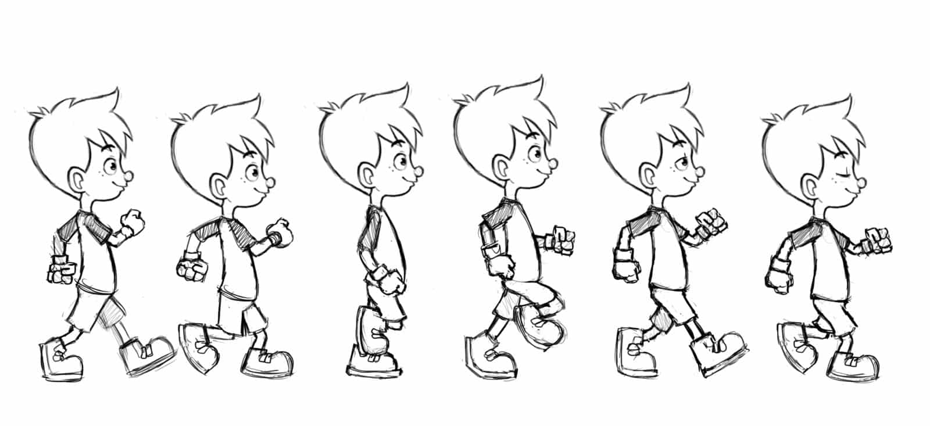

**Formats of principles :-**

* MP4:-  is a file format created by the Moving Picture Experts Group (MPEG) as a multimedia container format designed to store audiovisual data.
* MOV:- is a multimedia container file format developed by Apple and compatible with both Macintosh and Windows platforms. It can contain multiple tracks that store different types of media data and is often used for saving movies and other video files.
* GIF:- is an image encoded in Graphics Interchange Format (GIF) which contains a number of images or frames in a single file and is described by its own graphic control extension. The frames are presented in a specific order in order to convey animation.
* Adobe After Effects**:-** is a digital visual effects, motion graphics, and compositing application developed by Adobe Systems and used in the post-production process of film making and television production.It can be used for keying, tracking, compositing and animation.
* CSS (Cascading Style Sheets):-make it possible to animate transitions from one CSS style configuration to another. We use these a lot in our Headless CMS websites.

